1. Develop a system using UML for Passport Management System; it should verify the passport details of the applicant by the central computer. The details regarding the passport will be provided to the central computer and the computer will verify the details of the applicant and provide approval to the office. Then the passport will issue from the office to the applicant.
2. Activity diagram: -

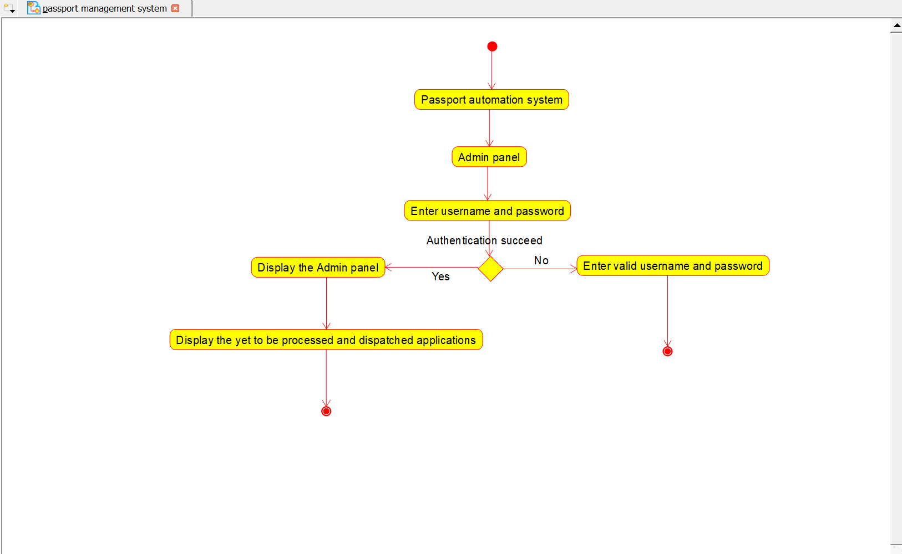

1. Class diagram: -

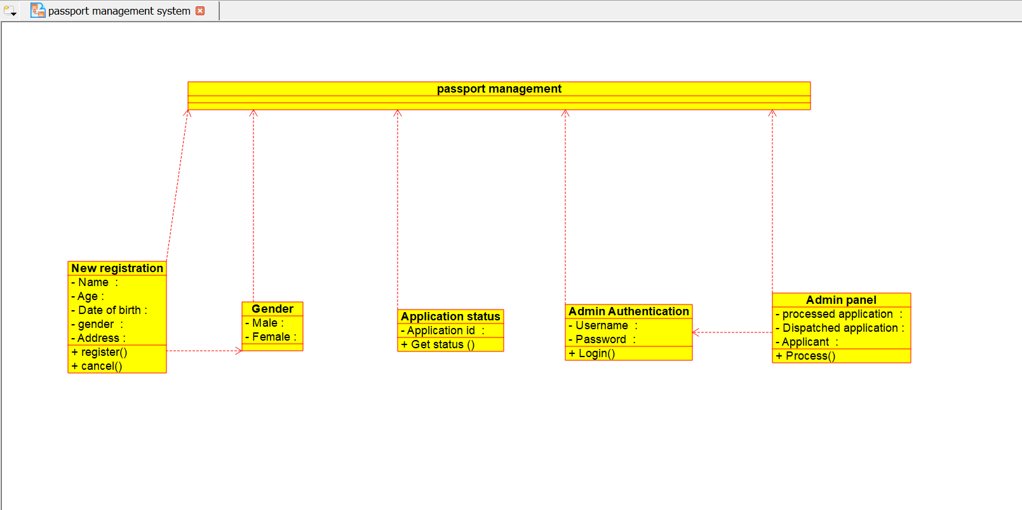

3)Sequence diagram:-

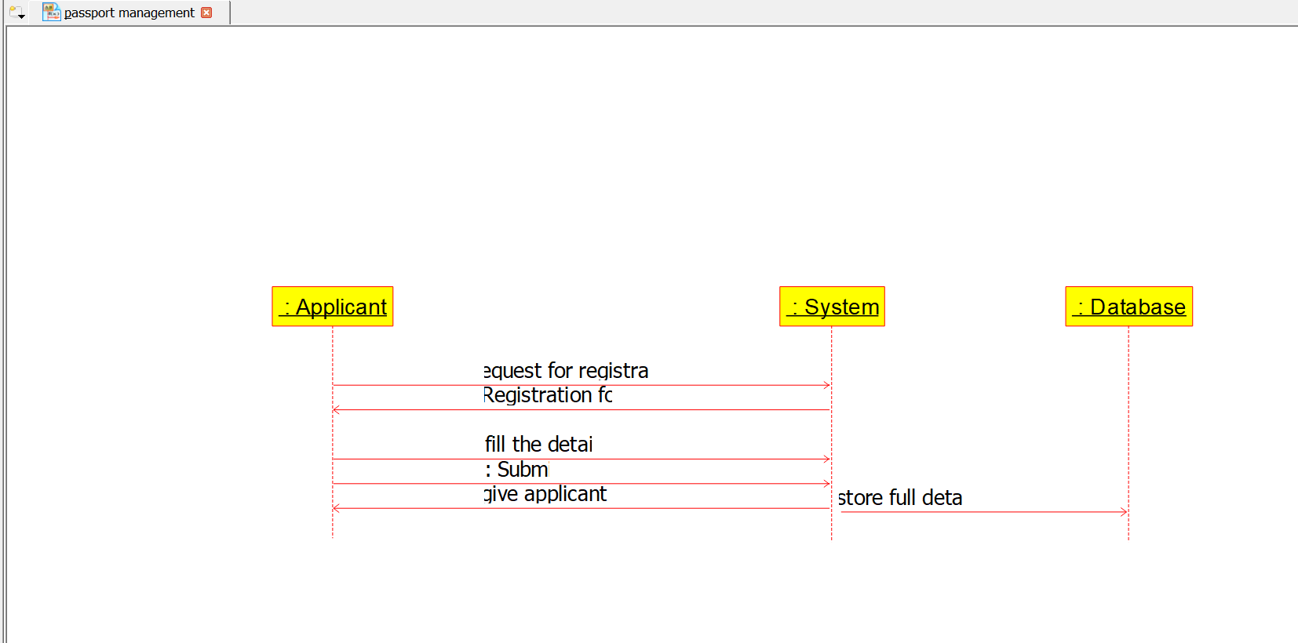

4)Use case diagram: -

